AP CSP Python with CodeX  Functions with Parameters #1 Activity Guide |  | Name:
Review: Functions
Write three or more things you know about functions.

Functions with Parameters #1 Examples
Go through the slides for Example #1. Take notes as needed in the space provided.

Go through the slides for Example #2. Take notes as needed in the space provided.

Go through the slides on local variables. Take notes in the space provided as needed.

On slide 28, you are given functions from the Pixels1_parameters program. | Identify the parameters and local variables in the first function: turn_pixels():  Parameters  Local variables  Identify the parameters and local variables in the second function: random_color(). Can you also identify the arguments?  Parameters  Local variables  Write a possible function call for the two functions that are called in random_color():  random.randrange()  turn_pixels()
Check for Understanding:
Function:  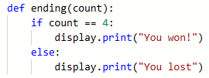 |  | Identify the parameters and local variables for this function.  Parameters  Local Variables  Give a possible function all for the function:

